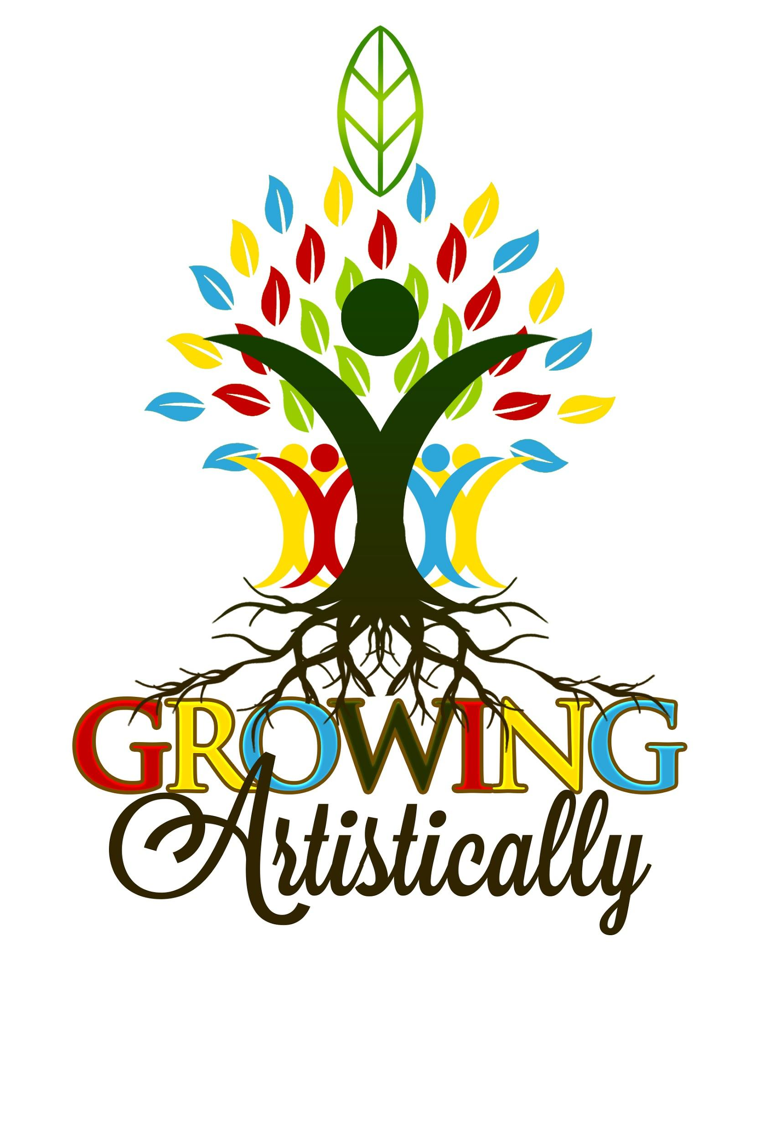

ART SUBMISSION FORM

YEAR 2020 Ages 9-18

Growing Artistically wants to advocate for youth creative/ entrepreneurs by showcasing their talents and raising money for their future. Creations will be visible on our website and hung for community events at our OTR location. This is an amazing opportunity for your child/student to sell their work for a profit and become sponsored globally!

**A CASH prize is given to one lucky student every showing for outstanding work and articulation of concept.**

Gallery Submission Process

1) Greater Cincinnati Youth Artists of all expressions (visual, verbal, musical, video, photography, poetry, fashion, ceramics etc.) are invited to participate. Youth entrepreneurs and creatives encouraged!

2) Registration fee of $25 to become sponsored on our site and submit work for sale. (You can ask your art teacher or school if they would donate toward your fee.) You’re representing your school community and the projects you likely make in class.

3) **Members** may submit personal works that have to do with **youth mental health awareness. For example, bullying, emotions, friendship, family, positivity, peace, love, social justice, change, etc.**

* Access to entrepreneur mentoring. Visit [www.growingartistically.org](http://www.growingartisticallypsmd.org/)

4) ​All submissions will be considered and we will make every attempt to include all work, provided they adhere to the theme, are inclusive, and space permits.

5) All work considered for the monthly prize is due by the first week of each month, youth artists can submit work for sponsorship any time throughout the year in the following ways:

1. Digitally by emailing Maria Green at mariagreen.ga@gmail.com
2. Stopping by the gallery (days/times) by appointment
3. Arranging for in-person pick up by calling
4. Donation/Referral from school art teacher

If you need additional information, have questions or suggestions, please contact: mariagreen.ga@gmail.com, Growing Artistically.

**THANKS!!!!**

**Please participate and make your voice heard! Please help spread the word!**

**ARTIST MEMBERSHIP APPLICATION SHEET**

Name:________________________________________________________________

Address:_______________________________________________________________

Telephone:___________________________email:_____________________________

Registration Fee: $ 25.00

Monthly membership Fee: WAIVERED

Cash:_____

Credit:_____

Paypal @growingartistically

**To become a youth member of Growing Artistically,** please write **a 5 line maximum bio/statement about your works and its relationship to youth mental health awareness. For example, bullying, emotions, friendship, family, coping skills, positivity, peace, love, justice, etc.**

**____________________________________________________________________________________________________________________________________________________________________________________________________________________________________________________________________________________________________________________________________________________________________________________________________________________________________**

**ARTWORK SUBMISSION INFORMATION SHEET**

Student’s Name:________________________________________________________

Parent/ Gaurdian:___________________________________________________________________

Address:_______________________________________________________________

Telephone:___________________________Email:_____________________________

**Please list the works you would like to submit and the worth:**

1. Title:​_____________________________________

For Sale/Not for Sale ***(please circle one)*** Price $_______

Medium: ___________________________________

Display Dimensions (HxWxD):________

Description:____________________________________________________________

______________________________________________________________________

______________________________________________________________________

2. Title:​______________________________________

For Sale/Not for Sale***(please circle one)*** Price $_______

Medium: ___________________________________

Display Dimensions (HxWxD):_________

Description:____________________________________________________________

_________________________________________________________________________

_________________________________________________________________________

**THANKS!!!!!!**

Please pass this form along to other possibly interested

artists. Please help spread the word!