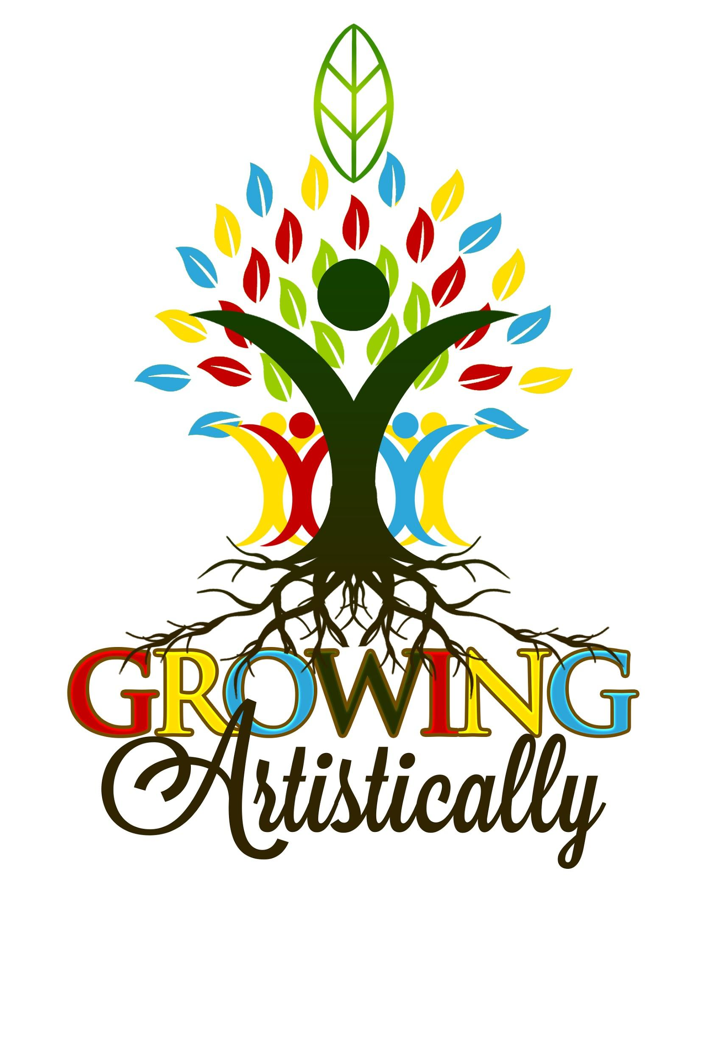

2020 SUBMISSION FORM

Growing Artistically wants to advocate for creatives/ entrepreneurs by showcasing their talents and raising money for their future. Creations will be visible on our website and on our social media. *This is an amazing opportunity for a child/student to sell their work for a profit and become sponsored globally!

# **Submission Process**

1) Artists of all expressions can fill out/ submit an application on our website by clicking SPONSOR @ [www.growingartistically.org](http://www.growingartistically.org) Participants may submit two visual, verbal, musical, video, photography, poetry, fashion, or ceramic etc. per month.

2) TAKE A PHOTO OF YOUR APPLICATION and creation. (Applicants under 18 must submit a photo/media release (attached) to become sponsored on our site and to submit work for sale.)

3) Go on our website and click SPONSOR, scroll down to the button “Submit Application” and submit! [www.growingartistically.org](http://www.growingartisticallypsmd.org)

*​All submissions will be considered and we will make every attempt to include all work, provided they adhere to the theme, and inclusive.*

**THANKS!!!!**

**Please participate and make yourself heard! Pass along, help share the word!**

**APPLICATION**

Name:________________________________________________________________

Parent/ Guardian (under 18):_________________________________________________________

Address:_______________________________________________________________

Telephone:___________________________Email:_____________________________

**If you would like to kindly donate without being a part of the showcase- donations can be made on our website or through paypal @GrowingArtistically.**

**To become sponsored by Growing Artistically,** please write **a 5 line maximum bio/statement about yourself and your works, including its relationship to mental health awareness. For example, bullying, emotions, friendship, family, coping skills, positivity, peace, love, justice, etc.**

**____________________________________________________________________________________________________________________________________________________________________________________________________________________________________________________________________________________________________________________________________________________________________________________________________________________________________**

**INFORMATION ABOUT YOUR CREATION**

**Please list the works you would like to submit and sale price:**

1. Title:​_____________________________________

For Sale/Not for Sale ***(please circle one)*** Price $_______

Medium: ___________________________________

( visual, verbal, musical, video, photography, poetry, fashion, ceramic etc. )

Description:____________________________________________________________

______________________________________________________________________

______________________________________________________________________

2. Title:​______________________________________

For Sale/Not for Sale***(please circle one)*** Price $_______

Medium: ___________________________________

(visual, verbal, musical, video, photography, poetry, fashion, ceramic etc.)

Description:____________________________________________________________

_________________________________________________________________________

_________________________________________________________________________

Media Release

Growing Artistically is a non-profit organization that provides evidence- based art therapy programs with holistic, empowering, and motivational projects. We document our programming with pictures, videos and reports. Therefore, we often take pictures and videos of our classes, events and camps for our website, brochures, and social media.

If you feel that you DO NOT want your child to be included in photos or videos, we will exclude your child/children when taking photographs or videos. Please keep in mind that we have no control over the public entities. If someone takes a picture or video of and participants performing (e.g. News media or general public).

***Please check the appropriate box below:***

□ **OPT OUT – NO, I DO NOT** want my child/children photographed or recorded for Growing Artistically media marketing and fundraising materials.

□ **OPT IN – YES,** my child/children may be photographed or recorded for Growing Artistically media marketing and fundraising materials.

_________________________________________ _____________________

Parent Signature Date

__________________________________________ ______________________

Director Date

**THANK YOU!!!!!!**

Please pass this form along to other possibly interested

creatives. Please help share the word!